Homework 4. B+ tree

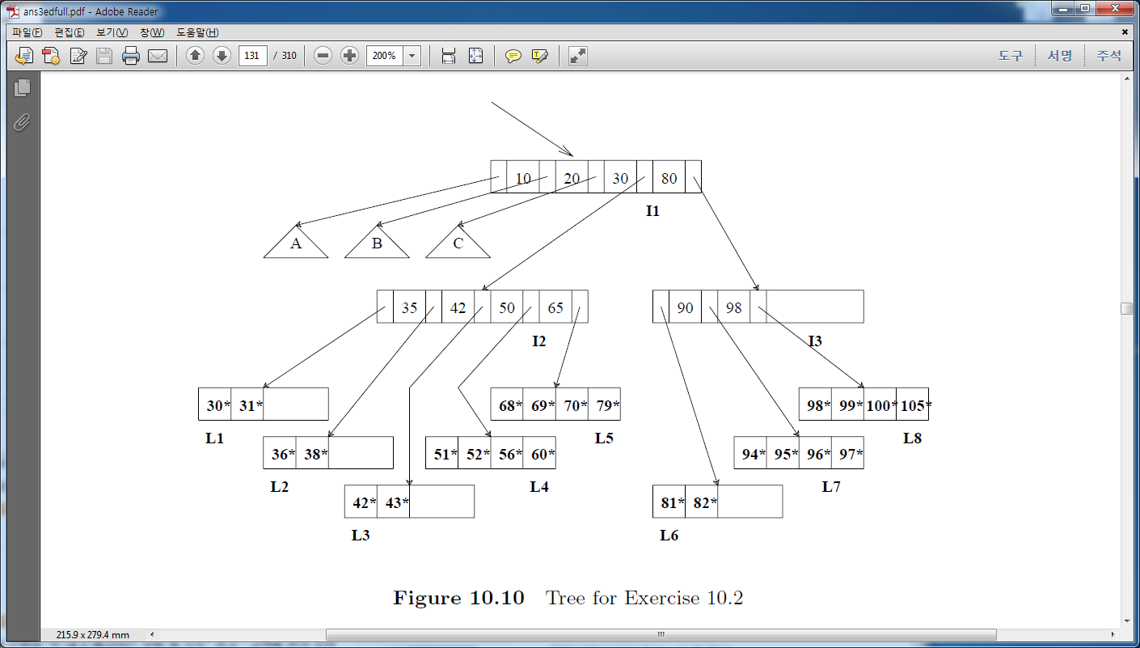

Consider the B+ tree index shown in Figure above, which uses Alternative (1) for data entries. Each intermediate node can hold up to five pointers and four key values. Each leaf can hold up to four records, and leaf nodes are doubly linked as usual, although these links are not shown in the figure. Answer the following questions.

1. Name all the tree nodes that must be fetched to answer the following query: “Get all records with search key greater than 38.”

=> I1,I2,I3,L1~L3

2. Show the B+ tree that would result from inserting a record with search key 109 into the tree.

3. Show the B+ tree that would result from deleting the record with search key 81 from the original tree.

=>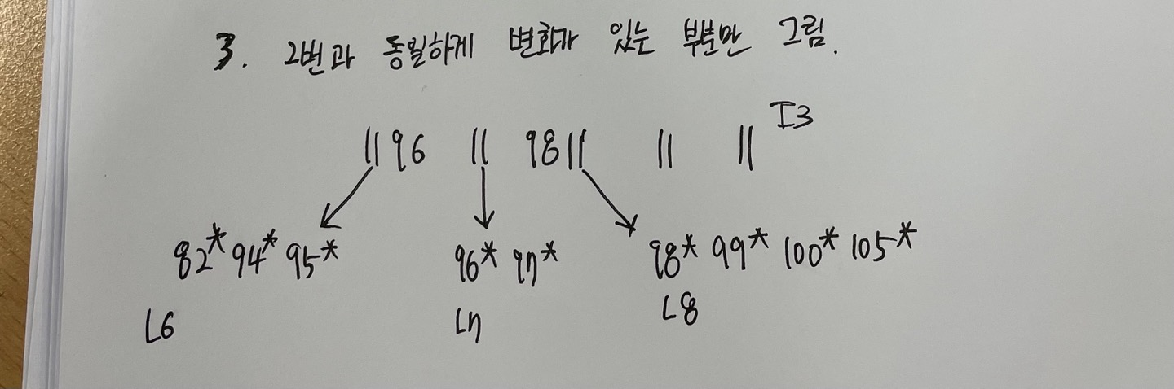

4. Name a search key value such that inserting it into the (original) tree would cause an increase in the height of the tree.

=> 78

5. Note that subtrees A, B, and C are not fully specified. Nonetheless, what can you infer about the contents and the shape of these trees?

=> leaf node의 최소 개수가 2개 최대 개수가 4개이므로 d=2 임을 알 수 있다. 또한 A에는 10미만의 key 값이, B에는 10이상 20 미만의 key 값이, C에는 20 이상 30미만의 key 값이 들어갈 수 있음을 추론할 수 있다.

6. How would your answers to the preceding questions change if this were an ISAM index?

=>

(1) B+Tree 와 동일

(2) L8 밑에 overflow page 가 생기고 109가 저장된다.

(3) L6에서 81이 삭제된다. (ISAM은 B+Tree 와 다르게 최소 보유 노드 제한이 없다.)

(4) L4,L5,L7,L8 노드에 들어갈 수 있는 수를 추가하면 overflowa page가 생기면서 height 가 증가한다.

7. Suppose that this is an ISAM index. What is the minimum number of insertions needed to create a chain of three overflow pages?

=>L4,L5,L7,L8 노드 중 하나를 선택하고 해당 범위에 들어갈 수를 9개째 넣는 순간 three overflow page가 생긴다.